CÁC SỰ KIỆN CỦA CÁC QUỐC GIA

**Tên sựu kiện : Lễ hội đua voi**

**Quốc gia :VIỆT NAM**

**MÔ TẢ NGẮN** : Tranh tài bởi những chú voi , mang ý nghĩa tôn vinh linh vật của VIỆT NAM

**Mô TẢ** : Elephant racing festival in Vietnam is a traditional event that dates back hundreds of years. This is a special festival that takes place in elephant villages in Vietnam such as Do Son (Hai Phong), An Thuong (Hue) and Bac Ninh.

During the festival, the elephants are beautifully and majestically decorated with colorful paintings and flowers. Elephants, a precious mascot in Vietnamese culture, are carefully prepared before entering the race.

The elephant racing competition takes place on a long and wide track. Spectators from neighboring areas and tourists both at home and abroad flock to witness the competition of carefully trained elephants. Talented and agile elephants rush onto the track, run at high speed and sometimes create dramatic fights.

The elephant racing festival is not only an interesting entertainment event but also has the meaning of protecting and honoring the national mascot. In addition to elephant racing, the festival also has other traditional cultural activities such as puppet shows, folk arts and unique art forms. This is an opportunity for people to understand and pay respect to Vietnamese history and culture.

**THỜI GIAN DIỄN RA :** Từ 12-14 /3

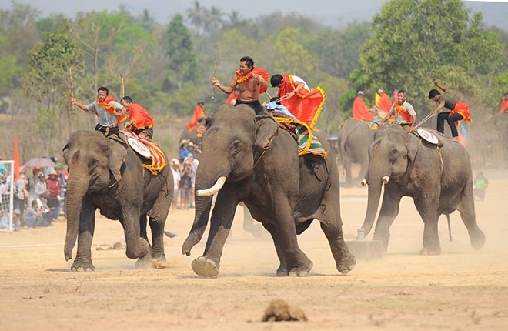

**Tên sựu kiện : Lễ hội TẠT NƯỚC**

**Quốc gia : THÁI LAN**

**MÔ TẢ NGẮN** : Tranh tài bởi những chú voi , mang ý nghĩa tôn vinh linh vật của VIỆT NAM

**Mô TẢ Lễ :** **The water throwing festival in Thailand, also known as Songkran, is a traditional festival that takes place every year from April 13 to 15. This is an opportunity to welcome the new year and clean up all the ugly things. During this festival, people participate in the activity of splashing water on each other, using water and water sprayers to vigorously water each other on the streets. This activity represents the meaning of washing away all evil spirits and bringing luck for the new year. Songkran also includes religious and family rituals, such as visiting relatives and participating in rituals at temples. This festival attracts large participation from people and tourists, creating a joyful, vibrant and interesting atmosphere for the Thai community.**

**THỜI GIAN DIỄN RA : 13-15/5**

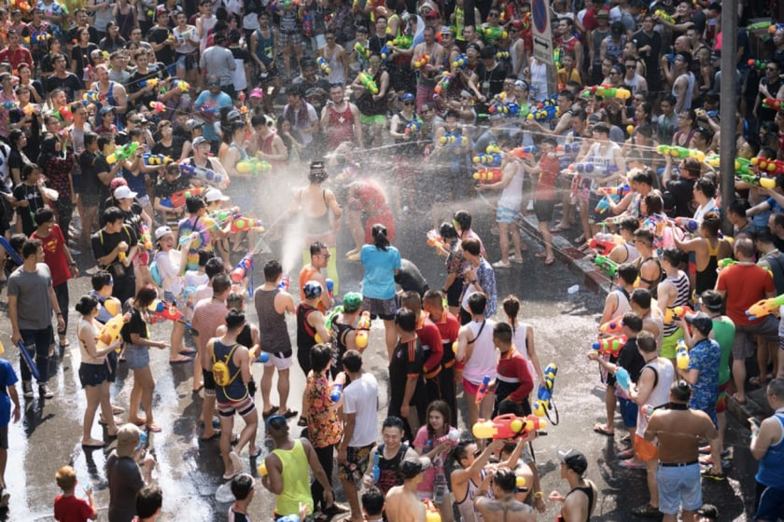

### Tên sựu kiện :  Lễ hội Hanami

**Quốc gia : JAPAN**

**MÔ TẢ NGẮN** :

**Mô TẢ : : The Hanami Festival is a traditional festival in Japan where people go out to enjoy the sight of cherry blossoms in full bloom. The word "Hanami" means "enjoying flowers" in Japanese. This festival usually takes place in spring, when cherry blossoms begin to bloom all over the country.**

**During the Hanami festival, flower gardens and parks become popular destinations for residents and tourists. People often gather under the rows of cherry trees to enjoy the beautiful scenery of blooming cherry blossoms and flower carpets: The Hanami Festival is a traditional festival in Japan where people go out to enjoy the sight of cherry blossoms in full bloom. The word "Hanami" means "enjoying flowers" in Japanese. This festival usually takes place in spring, when cherry blossoms begin to bloom all over the country.**

**During the Hanami festival, flower gardens and parks become popular destinations for residents and tourists. People often gather under the rows of cherry trees to enjoy the beautiful scenery of blooming cherry blossoms and flower carpets**

**THỜI GIAN DIỄN RA :cuói tháng 3 đầu tháng 4**

**Tên sựu kiện :** lễ tạ ơn

**Quốc gia : USA**

**MÔ TẢ NGẮN** : Tranh tài bởi những chú voi , mang ý nghĩa tôn vinh linh vật của VIỆT NAM

**Mô TẢ** : Thanksgiving is an important holiday celebrated in the United States on the fourth day of November every year. This festival is considered one of the most important holidays and attracts the participation of Americans.

Thanksgiving has its roots in history hundreds of years ago, when the Pilgrims, who migrated from England to settle in America, held a party to give thanks and share with the indigenous people. red helped them in growing wheat. Since then, Thanksgiving Day has become an opportunity for people to give thanks for the good things in life and express gratitude for their family, friends and achievements.

During Thanksgiving, every American family often gathers to enjoy a traditional thanksgiving feast. The main dish is usually turkey with side dishes such as mashed potatoes, cranberry sauce, cornbread, sausage, steamed mushrooms, and brownies. Everyone expressed gratitude and shared joy, together creating a cozy and united space on this occasion.

Thanksgiving is also a busy shopping time, with many Americans taking advantage of big sales the next day, known as Black Friday. In addition, Thanksgiving also marks the beginning of the year-end holiday season, from Thanksgiving to Christmas and New Year.

Thanksgiving is important in American culture, creating an occasion for people to enjoy time with family and loved ones, while expressing gratitude and social solidarity.

**THỜI GIAN DIỄN RA : THỨ 4 THÁNG 11**

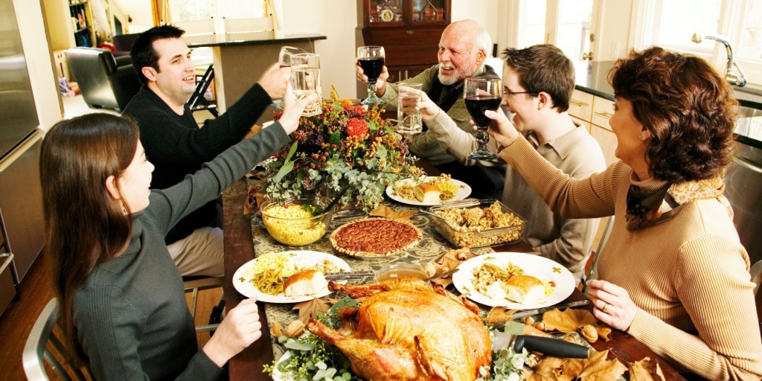

### 

### Tên sự kiện: Lễ hội Diwali

**Quốc gia : ẤN ĐỘ**

**MÔ TẢ NGẮN** :

**Mô TẢ : The festival of Diwali, also known as Deepavali, is one of the biggest and most important festivals of India. Diwali celebrates the victory of light and wisdom over darkness and Ignorance. It lasts for 5 days and is celebrated in October or November, according to the Hindu calendar.**

**The festival begins with the earth-smoking ceremony and cleaning of the house to prepare for the welcome of goddess Lakshmi, goddess of wealth and fortune. People place incense sticks, incense sticks and star lamps on their doorsteps and in their homes to welcome goddess Lakshmi and to remove any negative energy. Lamps and lights are prevalent everywhere, creating a vibrant and bright scene.**

**The main holiday is on the night of the full moon, people wear new clothes and attend religious ceremonies at temples, Hindu temples or Sikh churches. People participate in parades, musical performances, and dazzling fireworks. Additionally, people exchange gifts and enjoy sweet traditional foods such as mithai (candy) and special dishes.**

**Diwali is also an occasion to experience joy and connection among family and friends. People visit and meet each other, gather for parties and social interactions. The festival also comes with the decoration of houses and buildings with star fruit trees and flowers, creating a space full of color and excitement.**

**Diwali is not only a folk festival, but also has a deep religious meaning. For Hindus, Diwali is an occasion to pray for prosperity and peace, and to honor the gods Rama and Sita, the main characters in the Ramayana legend.**

**Overall, the Festival of Diwali is a combination of bright lights, joy, gratitude and religion. It creates a warm and exciting space for the people of India, symbolizing illumination and hope amidst darkness.**

**.**

THỜI GIAN ĐIEN RA :THÁNG 10 THÁNG 11

